**Logstash installation:**

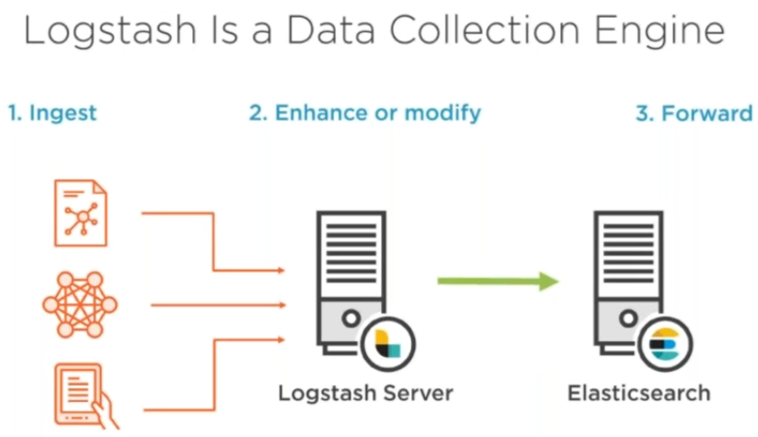

* From our logstash we will be configuring elastic search

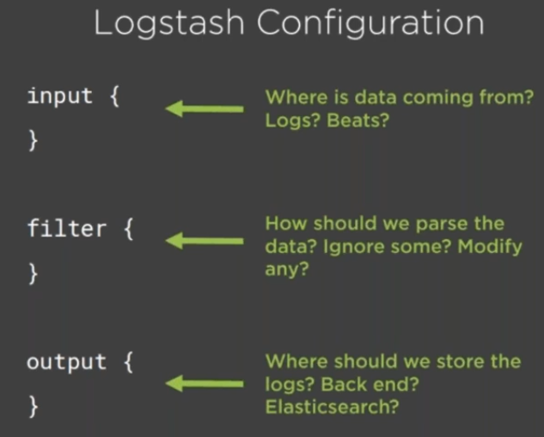

* Filter is used if we want to add something
* Input and output, filter in Logstash called plugins. We call them as Logstash plugins

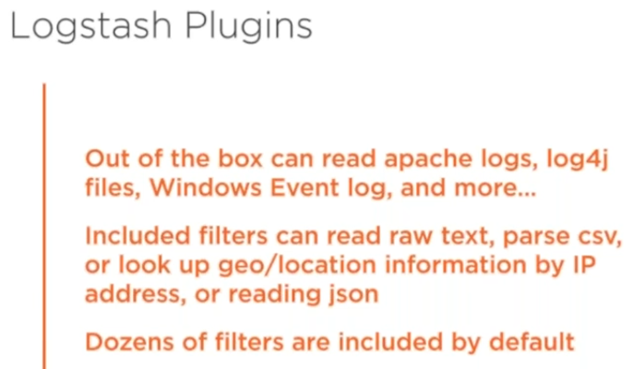

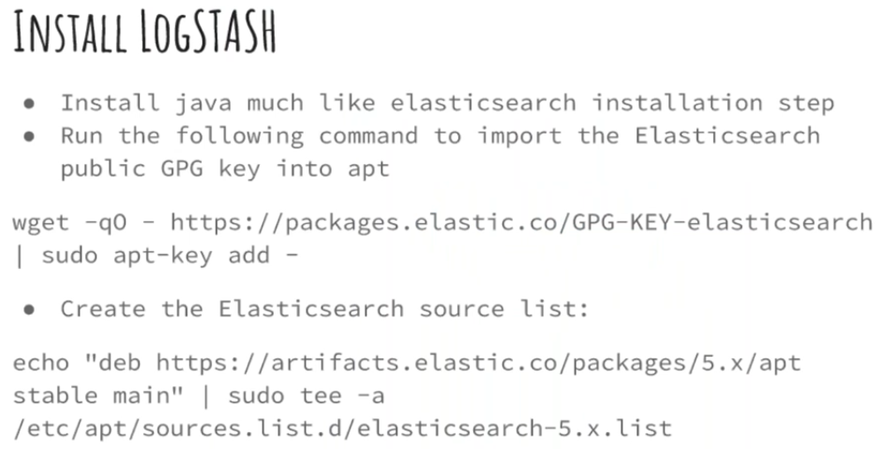

* We need java for Logstash also
* Install one more instance. T2 small is enough for this with 2 GB
* After that we need to download some packages as above command
* Also run echo command as above image

Now update packages and install logstash

* **Apt-get update**
* **Apt-get install logstash**

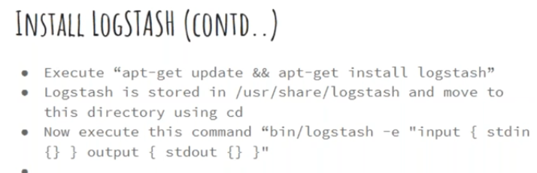

* Logstash basically installed on /usr/shate/logstash
* To check the logstash is working or not. Get into the folder and execute the above command
* With that command we are starting logstash and giving input and output. If it displays the input and output what we have given. Then it’s working fine as below

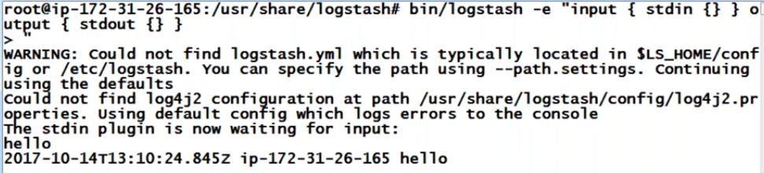

**Kibana:**

* Kibana is frontend. It does not hold any data



* It is written in node.js we can open it with any browser. It is free
* Pre-defined dashboard we can do it easily, but plugin related dashboards we need to know how to write plugin and how to include them
* Pre-defined dashboards are enough for us

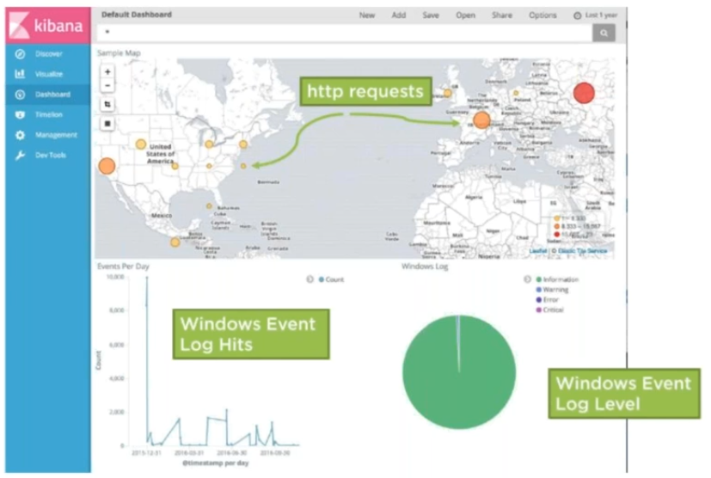

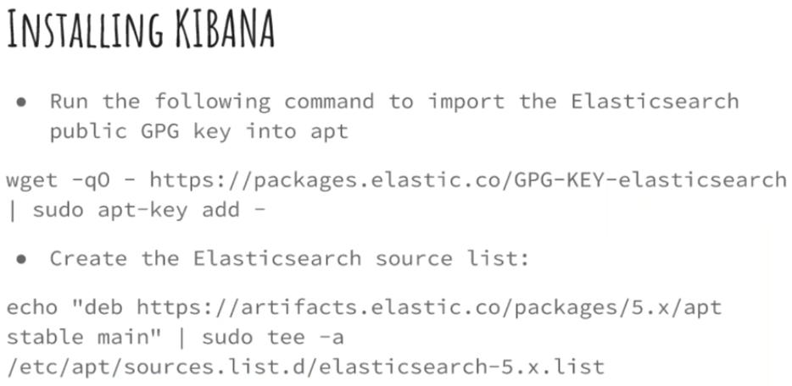

* Here we don’t need java
* Installation steps might change for Linux, but the locations will not
* Free server is also enough here. But heavier thing we need to have heavy server
* Run the above commands

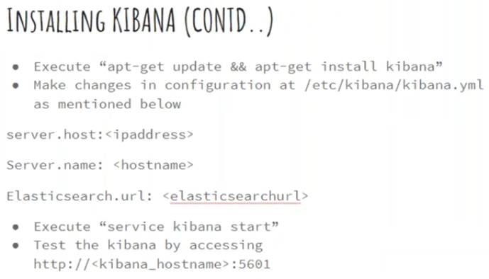

* Apt-get update and install kibana
* Then open kibana.yml configuration file
* Server.host, give private ip
* If we give localhost as ip. No one from outside can open it. Admin can login to the server and can access with browser
* Serer.name, give DNS name
* In elasticsearch.url, give elastic server ip and port as below



* Now, service kibana start
* We can access it <http://ip:5600>
* Now, it won’t show anything as there is no data in elastic search